Autologous oral mucosal epithelial cells in the treatment of limbal stem cell deficiency
Deficiency of limbal stem cells (LSCs) of the cornea [1] leads to chronic ocular pain and loss of vision, amongst other debilitating symptoms. Current therapeutic options include the transplantation of LSCs from the uninjured eye [2], which prevents an obvious risk of deficiency in both eyes if the procedure fails, or the transplantation of autologous ex vivo expanded LSCs [3]. However, these options are not applicable for patients with bilateral and total LSCD, and so other therapeutic options are being evaluated. One of these is the use of oral mucosa epithelial (OME) cells as an alternative source of autologous epithelium, and epithelial stem cells, which have been clinically studied (see original article for extended references), but present with problems which include the use of animal products in the cell expansion phase. Now, researchers from the group of Majlinda Lako from the Institute of Genetic Medicine, Newcastle University, UK, have developed a reproducible, safe feeder‐ and animal product‐free system for the expansion of OME under good manufacturing practice (GMP) requirements and report on the transplantation of expanded cells in two patients with bilateral total LSCD [4].
Normal human mucosa is thicker than corneal epithelium, but it does express the putative epithelial and limbal stem cell marker p63 in the basal layer and Cytokeratin 3 (CK3), a marker of corneal differentiation, but not CK19, a marker of conjunctival and limbal epithelial cells. The group could culture single cell suspensions of OME, generating colonies of stem cell-like cells on a mouse fibroblast feeder layer in the presence of foetal calf serum (FCS), but long term culture led to the appearance of differentiated cell types. Replacement of the feeder layer with human amniotic membrane (HAM) did not allow for good colony growth, and so the researchers turned to the expansion of biopsied explants instead, which allowed for excellent outgrowths for all biopsies assessed. The air lifting technique to create cell sheets from the explant/HAM culture generated physically durable and manageable sheets with well‐stratified epithelial layers (3‐7 layers). Additionally, cells within the sheets expressed several putative epithelial stem cells markers (ΔNp63α, ABCG2, C/EBPδ) and CK3, but lacked the expression of unique corneal epithelial markers (CK12 and PAX6), suggesting a general epithelial stem cell phenotype. Transmission electron microscopy also demonstrated that cells adhered to each other (through desmosomes) as well as the basement membrane (through hemidesmosomes) and also displayed appropriate surface specialisations allowing interaction with the tear film (microplicae), similar to limbal stem cells. Replacement of FCS with human autologous serum (HAS) led to the generation of colonies with greater efficiency on mouse feeders, while use of HAS and HAM mediated the production of a 3‐7 layer well‐formed epithelium with stem cell-like cells which expressed the p63, the nuclear proliferative market Ki67, the stem cell marker ABCG2 and CK3. The attached figure represents the histological and immunohistochemistry analysis of the ex vivo oral epithelium of one patient. This process was also deemed viable and productive after the group translated the procedure to an the Human Tissue Authority (HTA) compliant GMP stem cell laboratory, so as to allow the clinical transplantation of OME epithelial sheets to two patients with total bilateral LSCD caused by chemical burns.
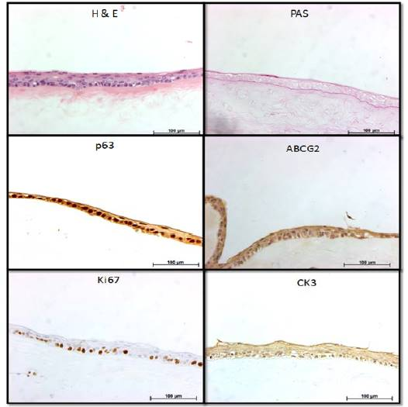
In both patients, transplantation mediated the generation of a stable epithelium with a reduction in both patients’ pain score. Patient 1 reported a significant visual improvement in the operated right eye, although the vision impairment score remained the same in the second patient due to central sub‐epithelial haze in the grafted cornea secondary to a few initial episodes of recurrent epithelial erosion. HLA matched corneal grafting after the OME transplant led to the existence of stable epithelium with superficial expression of CK3, basal expression of p63 and Ki67 and complete absence of conjunctival marker MUC5A, suggesting a restoration of corneal surface of patients with total bilateral LSCD.
The authors note that this is the first report of generation of multi‐layered OME-derived epithelium under feeder‐ and animal product free conditions. Excitingly, they also found that this autologous epithelium was able to restore ocular surface of bilateral LSCD patients. The autologous nature of the cells is an important factor as this precludes the use of systemic immunosuppression with its associated side effects. The authors do note the limited scope of this report (two patients) and are working towards performing this procedure on a larger number of patients in order to reach definitive conclusions on the safety and efficiency of this technique.
Discussion Points
- Are there other situations where an alternative stem cell source may be therapeutically relevant?
- Will this strategy prove to be utile/feasible when expanded to a larger cohort of patients?
- Are there other epithelial cell sources which may prove to be functionally superior?
References
- Ahmad S, Figueiredo F, and Lako M Corneal epithelial stem cells: characterization, culture and transplantation. Regen Med 2006;1:29-44.
- Holland EJ Epithelial transplantation for the management of severe ocular surface disease. Trans Am Ophthalmol Soc 1996;94:677-743.
- Kolli S, Ahmad S, Lako M, et al. Successful clinical implementation of corneal epithelial stem cell therapy for treatment of unilateral limbal stem cell deficiency. Stem Cells 2010;28:597-610.
- Kolli S, Ahmad S, Mudhar HS, et al. Successful application of ex vivo expanded human autologous oral mucosal epithelium for the treatment of total bilateral limbal stem cell deficiency. Stem Cells 2014.

